Great! You're looking to create AWS ECS services using Fargate that can:
- Communicate between services
- Allow container-to-container communication within a task
- Use ECS Service Connect for DNS-based internal communication
Let me walk you through how to set this up end-to-end, using ECS + Fargate + Service Connect.

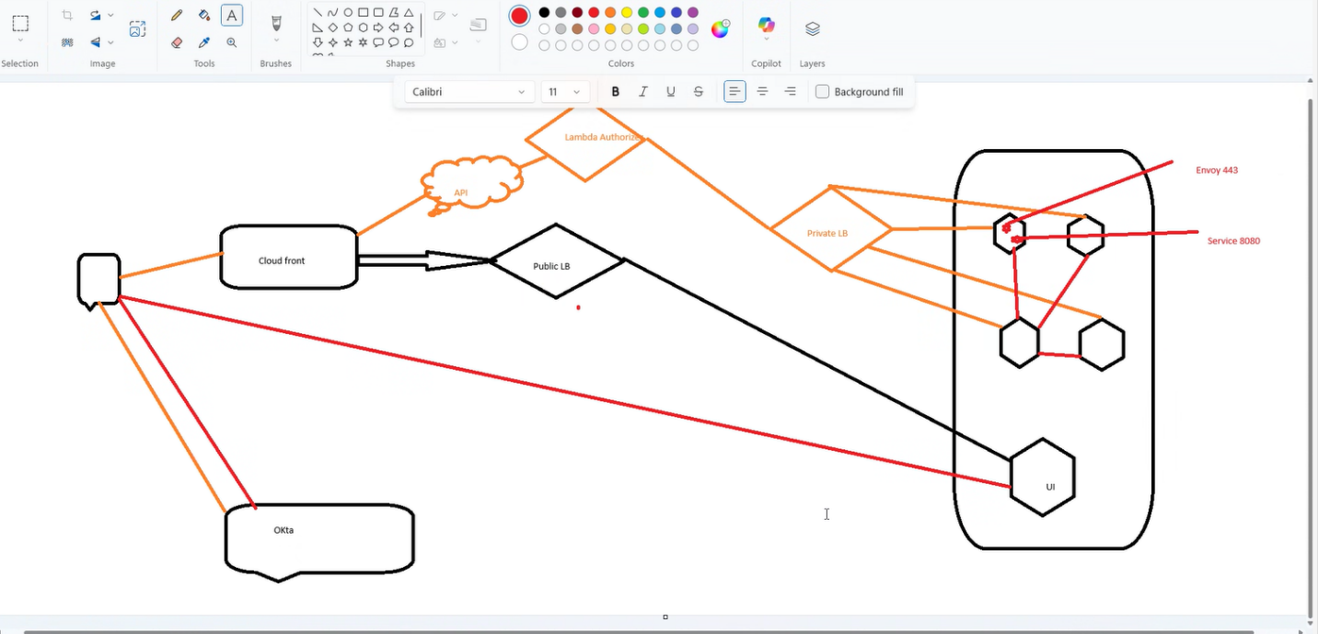

🔧 Architecture Overview
Let’s say you have two services:
- service-a (e.g., frontend)
- service-b (e.g., backend API)
You want:
- service-a to talk to service-b using http://service-b
- Containers within the same service/task to talk via localhost
- Everything running on Fargate using ECS Service Connect

🧱 Step-by-Step Setup

✅ Step 1: Create a Cloud Map Namespace
Service Connect uses AWS Cloud Map for service discovery.

In the AWS Console:
- Go to Cloud Map > Create namespace
- Choose:
  - Type: Private DNS namespace
  - Name: myapp.local
  - VPC: Choose the same VPC ECS will use
Or via CLI:
bash
CopyEdit
aws servicediscovery create-private-dns-namespace \
--name myapp.local \
--vpc vpc-xxxxxxxx \
--region us-east-1

✅ Step 2: Create the ECS Cluster with Service Connect Enabled
In AWS Console:
- Go to ECS > Clusters > Create Cluster
- Choose Networking only (Fargate)
- Enable Service Connect
- Choose the Cloud Map namespace you created (e.g. myapp.local)

✅ Step 3: Define the Task Definitions
Each ECS service runs a task definition. Here’s an example for a simple service with one container:

Example Task Definition (JSON):
{
"family": "service-a-task",
"networkMode": "awsvpc",
"requiresCompatibilities": ["FARGATE"],
"cpu": "256",
"memory": "512",
"containerDefinitions": [
{
"name": "service-a",
"image": "your-ecr-repo/service-a:latest",
"portMappings": [
{
"name": "http",
"containerPort": 3000,
"protocol": "tcp",
"appProtocol": "http"
}
]
}
]
}
Repeat similarly for service-b.

✅ Step 4: Create the Services with Service Connect
Each service must have Service Connect enabled.

Example: service-a ECS Service
"serviceConnectConfiguration": {
"enabled": true,
"namespace": "myapp.local",
"services": [
{
"portName": "http",
"discoveryName": "service-a",
"clientAliases": [
{
"port": 80,
"dnsName": "service-a"
}
]
}
]
}

Example: service-b ECS Service
"serviceConnectConfiguration": {
"enabled": true,
"namespace": "myapp.local",
"services": [
{
"portName": "http",
"discoveryName": "service-b",
"clientAliases": [
{
"port": 80,
"dnsName": "service-b"
}
]
}
]
}
Now service-a can call http://service-b securely inside the VPC.

✅ Step 5: Container-to-Container Communication in Same Task
If a service has multiple containers, they share the same ENI, so use localhost.
For example, in service-a-task:
json
CopyEdit
"containerDefinitions": [
{
"name": "app",
"image": "app-image",
"portMappings": [
{
"containerPort": 3000
}
]
},
{
"name": "sidecar",
"image": "sidecar-image",
"portMappings": [
{
"containerPort": 9000
}
]
}
]
From app, you can call sidecar with:
bash
CopyEdit
curl http://localhost:9000

🧪 Testing the Setup
- Deploy both services into the same ECS Cluster
- Shell into one container (via ECS Exec or add debug container)
- Try curl http://service-b
- Should resolve via internal DNS (service-b.myapp.local)

✅ Summary
Feature | How
Service-to-service communication | Use Service Connect + Cloud Map (http://service-name)
Intra-task communication | Use localhost:<port>
Security | All traffic stays within the VPC
Service Discovery | Managed via Cloud Map and ECS
Deployment | AWS Console, CLI, Terraform, CDK

